**Power BI Mini-Project Documentation**

**Title**

* Project Title: Health Care Data Analysis
* Name: Shamshunnisa M
* Date: [Submission Date]

**1. Project Overview**

* **Objective**: To analyse inpatient and outpatient waiting list of 3 years.
* **Dataset**: Patient data from 2018 – 2022 in .csv type, containing 9 columns in Inpatient and 10 in outpatient.
* **Tools Used**: Power BI

**2. Steps Involved**

1. **Data Import**:
   * I downloaded data from YouTube reference and imported .csv file to power BI.
2. **Data Transformation**:
   * Firstly, I cleaned all the null values and then there were some missing columns in inpatient and outpatient data so I added columns.
3. **Visualization**:
   * Pie chart
   * Stacked Bar Chart
   * Line Graphs
4. **Dashboard Design**:
   * I aligned all charts in a sequence that reader can read all things mentioned properly and to mention some specific numbers I included some cards.
   * As well I added some filters so that user can see data which he required.

**3. Key Insights**

* The total wait list has increased by 10.8% in a year, with outpatient cases dominating (74.36%).
* Dermatology and Accident & Emergency specialties have the longest wait times, while Pain Relief shows the shortest.
* The age group 16–64 faces the longest waiting period (over 18 months), while those aged 65+ generally wait under 3 months.
* Outpatient numbers consistently outpace Day Cases and Inpatients, fluctuating between 502K–629K over 3 years (July 2018–Jan 2021).

**4. Screenshots**

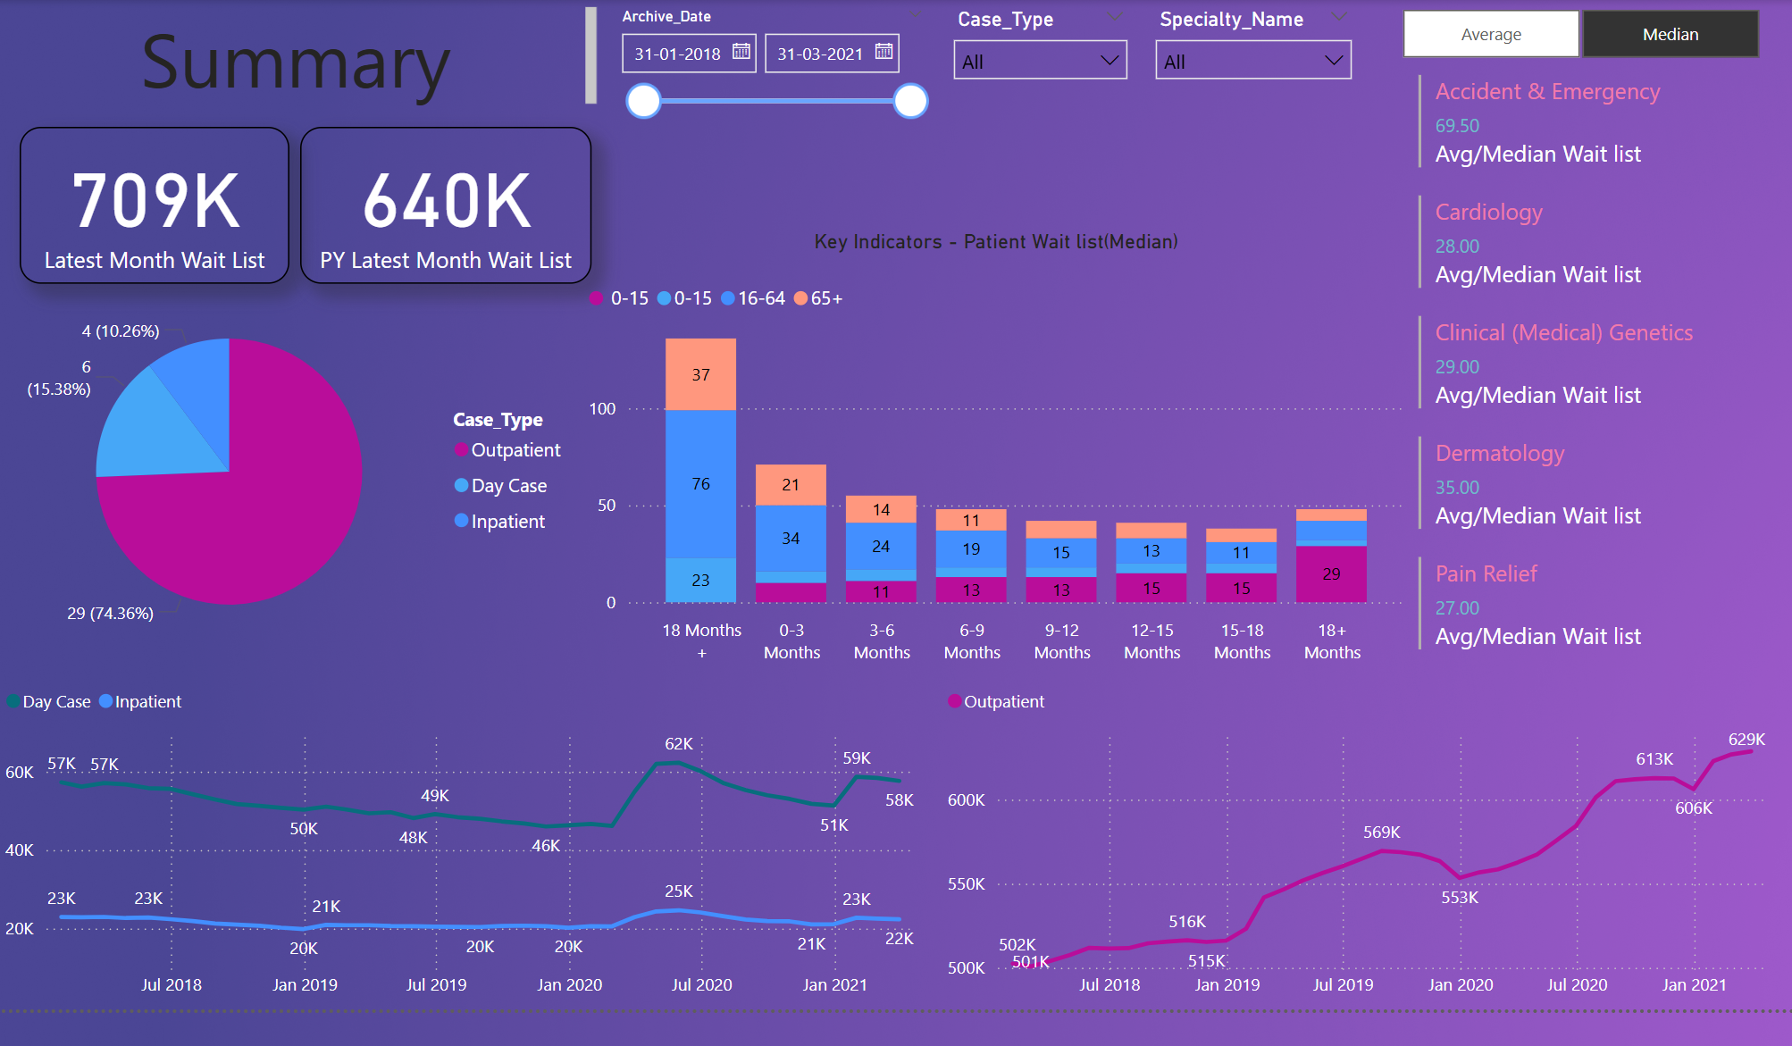

**5. Conclusion**

* The growing wait list indicates a need for systemic improvements in outpatient services.
* High-demand specialties like Accident & Emergency and Dermatology require prioritized interventions.
* Age-specific resource allocation could address delays for the 16–64 demographic and elderly patients.